TASK SCHEDULING APPLICATION

Team No: 26

*Project Report:*

**Abstract:**

**We have developed a project on task management system to help teams to organize their tasks, deadlines, and projects effectively. The system encompasses various entities such as tasks, users, projects, deadlines, priorities, and more, to provide users with a seamless experience in managing their tasks. It also facilitates collaboration among team members and offers notification features.** The system focuses on ten entities consisting tasks, resources, and scheduling details. Individual Java classes encapsulate the functionalities of each entity, with a driver class serving as the central point for scheduling and data management.



**Introduction:**

The task management system addresses the need for a centralized platform to improve personal and team productivity. By offering features like task organization, deadline setting, priority management, and collaboration tools, Alert Notifications and tracking our report time to time, the system empowers users to streamline their workflow and achieve their goals efficiently.

**Functional Requirements:**

**1. Task Management:** Users can create tasks, set deadlines, assign them to team members, and track their progress.

**2. Project Management:** Users can organize tasks into projects, allowing for better organization and collaboration.

**3. Deadline Tracking:** The application helps users keep track of deadlines and ensures tasks are completed on time.

**4. Priority Management:** Users can assign priority levels to tasks, helping them focus on high-priority items.

**5. Subtask Management:** Users can break down larger tasks into smaller subtasks for better organization and execution.

**6. Collaboration:** The application facilitates collaboration by allowing users to assign tasks to team members, share project updates, and communicate within the platform.

**7. Notifications:** Users receive notifications for upcoming deadlines, task assignments, and other relevant updates.

**8. Calendar Integration:** The application may integrate with calendars to provide users with a visual representation of their tasks and deadlines.

**9. Reporting:** Users can generate reports to analyse task completion rates, project progress, and team productivity.

**10. User Management:** Users can register, log in, and manage their accounts, including updating their profile information and resetting passwords.

**ER DIAGRAM:**

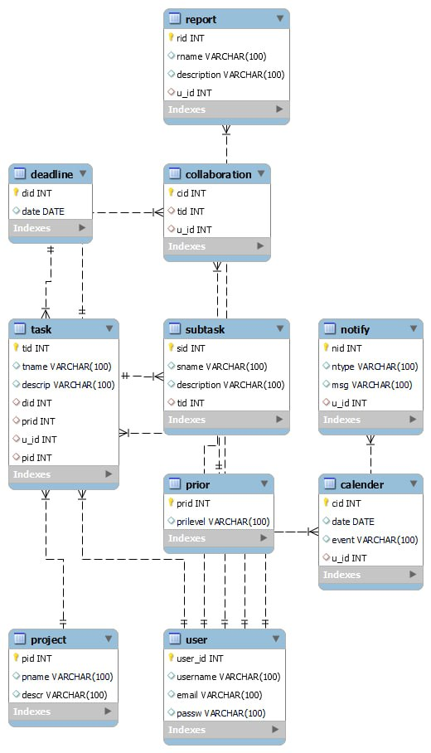

**QUERIES TO CREATE DATA BASE:**

* **create database tasksschedulingapplication;**
* **use tasksschedulingapplication;**
* **create table user(user_id int primary key auto_increment,username varchar(100),email varchar(100),passw varchar(100));**
* **create table project(pid int primary key auto_increment,pname varchar(100),descr varchar(100));**
* **create table deadline(did int primary key auto_increment,date date );**
* **create table prior(prid int primary key auto_increment,prilevel varchar(100));**
* **create table calender(cid int primary key auto_increment,date date,event varchar(100),u_id int,foreign key(u_id) references user(user_id));**
* **create table report(rid int primary key auto_increment,rname varchar(100),description varchar(100),u_id int,foreign key(u_id)references user(user_id));**
* **create table notify(nid int primary key auto_increment,ntype varchar(100),msg varchar(100),u_id int,foreign key(u_id) references user(user_id) );**
* **create table task(tid int primary key auto_increment,tname varchar(100),descrip varchar(100),did int,foreign key(did) references deadline(did),prid int,foreign key(prid) references prior(prid),u_id int,foreign key(u_id) references user(user_id),pid int,foreign key(pid) references project(pid));**
* **create table subtask(sid int primary key auto_increment,sname varchar(100),description varchar(100),tid int,foreign key(tid) references task(tid));**
* **create table collaboration(cid int primary key auto_increment,tid int, foreign key(tid)references task(tid),u_id int,foreign key(u_id)references user(user_id));**

**UML/Class attribute & methods diagram:**

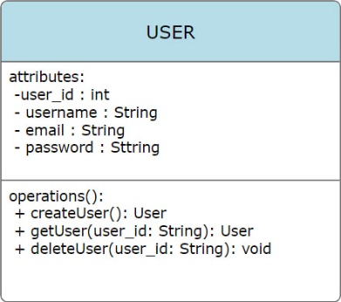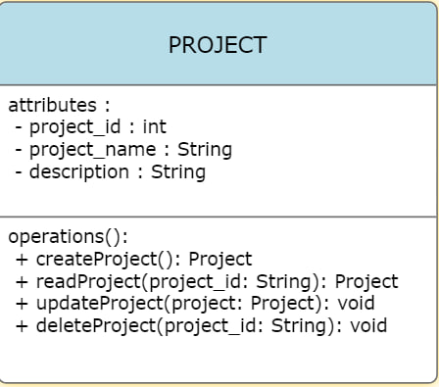

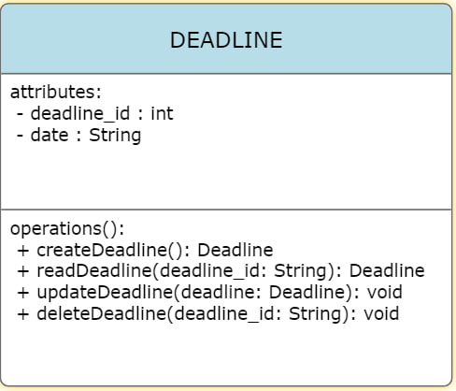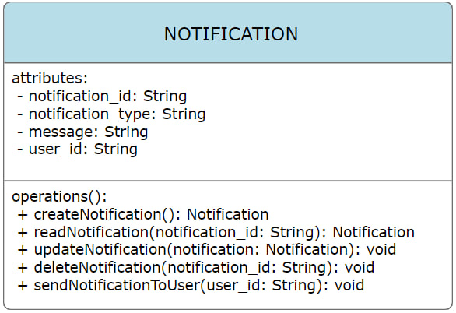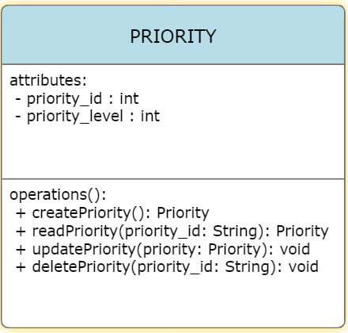

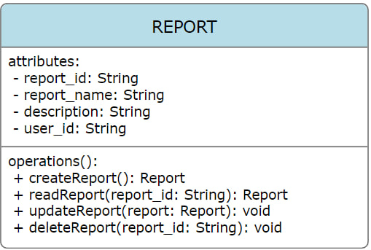

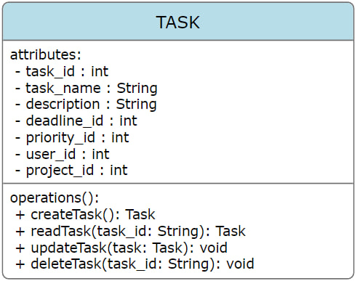

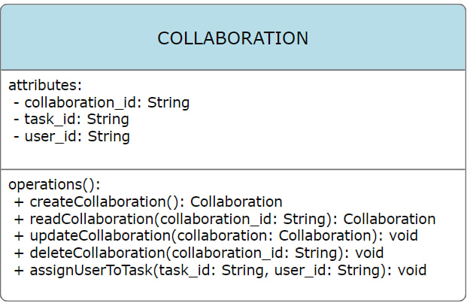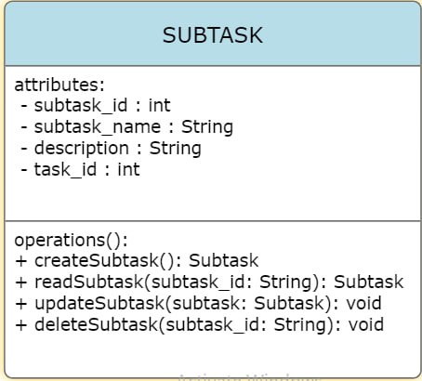

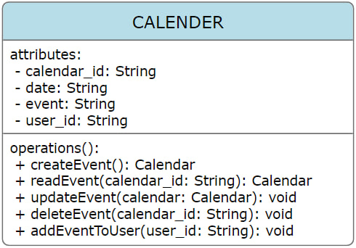

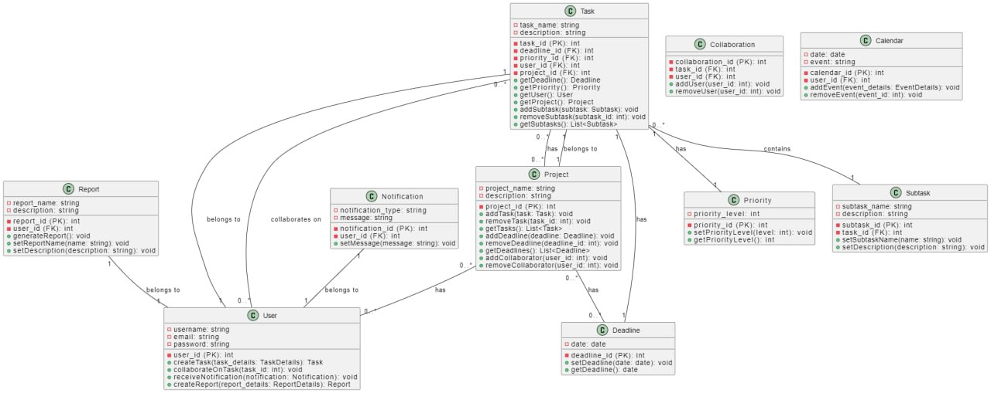

**All java classes:**

***-User.java***

package Task_scheduling_application;  
  
public class user {  
 private String user_id;  
 private String username;  
 private String email;  
 private String password;  
  
 public user(String user_id, String username, String email, String password) {  
 this.user_id = user_id;  
 this.username = username;  
 this.email = email;  
 this.password = password;  
 }  
  
 public String getUser_id() {  
 return user_id;  
 }  
  
 public void setUser_id(String user_id) {  
 this.user_id = user_id;  
 }  
  
 public String getUsername() {  
 return username;  
 }  
  
 public void setUsername(String username) {  
 this.username = username;  
 }  
  
 public String getEmail() {  
 return email;  
 }  
  
 public void setEmail(String email) {  
 this.email = email;  
 }  
  
 public String getPassword() {  
 return password;  
 }  
  
 public void setPassword(String password) {  
 this.password = password;  
 }  
 public void displayUser(){  
 System.*out*.println("User details:");  
 System.*out*.println("User ID: " + user_id);  
 System.*out*.println("Username: " + username);  
 System.*out*.println("Email: " + email);  
 System.*out*.println("Password: " + password);  
 }  
}

***-Project.java***

package Task_scheduling_application;  
  
public class project {  
 private String project_id;  
 private String project_name;  
 private String description;  
  
 public project(String project_id, String project_name, String description) {  
 this.project_id = project_id;  
 this.project_name = project_name;  
 this.description = description;  
 }  
  
 public String getProject_id() {  
 return project_id;  
 }  
  
 public void setProject_id(String project_id) {  
 this.project_id = project_id;  
 }  
  
 public String getProject_name() {  
 return project_name;  
 }  
  
 public void setProject_name(String project_name) {  
 this.project_name = project_name;  
 }  
  
 public String getDescription() {  
 return description;  
 }  
  
 public void setDescription(String description) {  
 this.description = description;  
 }  
  
 public void Projectdisplay() {  
 System.*out*.println("Project details:");  
 System.*out*.println("Project ID: " + project_id);  
 System.*out*.println("Project Name: " + project_name);  
 System.*out*.println("Description: " + description);  
 }  
}

***-Deadline.java:***

package Task_scheduling_application;  
  
public class DeadLine {  
 private String deadline_id;  
 private String date;  
  
 public DeadLine(String deadline_id, String date) {  
 this.deadline_id = deadline_id;  
 this.date = date;  
 }  
  
 public String getDeadline_id() {  
 return deadline_id;  
 }  
  
 public void setDeadline_id(String deadline_id) {  
 this.deadline_id = deadline_id;  
 }  
  
 public String getDate() {  
 return date;  
 }  
  
 public void setDate(String date) {  
 this.date = date;  
 }  
 public void Deaddlinedisplay() {  
 System.*out*.println("Deadline details:");  
 System.*out*.println("Deadline ID: " + deadline_id);  
 System.*out*.println("Date: " + date);  
 }  
}

}

**-Priority.java:**

package Task_scheduling_application;  
  
public class Priority {  
 private String priority_id;  
 private String priority_level;  
  
 public Priority(String priority_id, String priority_level) {  
 this.priority_id = priority_id;  
 this.priority_level = priority_level;  
 }  
  
 public String getPriority_id() {  
 return priority_id;  
 }  
  
 public void setPriority_id(String priority_id) {  
 this.priority_id = priority_id;  
 }  
  
 public String getPriority_level() {  
 return priority_level;  
 }  
  
 public void setPriority_level(String priority_level) {  
 this.priority_level = priority_level;  
 }  
 public void Prioritydisplay() {  
 System.*out*.println("Priority details:");  
 System.*out*.println("Priority ID: " + priority_id);  
 System.*out*.println("Priority Level: " + priority_level);  
 }  
}

**-Calender.java:**

package Task_scheduling_application;  
  
public class Calender {  
 private String calendar_id;  
 private String date;  
 private String event;  
 private String user_id;  
  
 public Calender(String calendar_id, String date, String event, String user_id) {  
 this.calendar_id = calendar_id;  
 this.date = date;  
 this.event = event;  
 this.user_id = user_id;  
 }  
  
 public String getCalendar_id() {  
 return calendar_id;  
 }  
  
 public void setCalendar_id(String calendar_id) {  
 this.calendar_id = calendar_id;  
 }  
  
 public String getDate() {  
 return date;  
 }  
  
 public void setDate(String date) {  
 this.date = date;  
 }  
  
 public String getEvent() {  
 return event;  
 }  
  
 public void setEvent(String event) {  
 this.event = event;  
 }  
  
 public String getUser_id() {  
 return user_id;  
 }  
  
 public void setUser_id(String user_id) {  
 this.user_id = user_id;  
 }  
 public void Calenderdisplay() {  
 System.*out*.println("Calendar Event details:");  
 System.*out*.println("Calendar ID: " + calendar_id);  
 System.*out*.println("Date: " + date);  
 System.*out*.println("Event: " + event);  
 System.*out*.println("User ID: " + user_id);  
 }  
  
  
  
}

**-Report.java:**

package Task_scheduling_application;  
  
public class Report {  
 private String report_id;  
 private String report_name;  
 private String description;  
 private String user_id;  
  
 public Report(String report_id, String report_name, String description, String user_id) {  
 this.report_id = report_id;  
 this.report_name = report_name;  
 this.description = description;  
 this.user_id = user_id;  
 }  
  
 public String getReport_id() {  
 return report_id;  
 }  
  
 public void setReport_id(String report_id) {  
 this.report_id = report_id;  
 }  
  
 public String getReport_name() {  
 return report_name;  
 }  
  
 public void setReport_name(String report_name) {  
 this.report_name = report_name;  
 }  
  
 public String getDescription() {  
 return description;  
 }  
  
 public void setDescription(String description) {  
 this.description = description;  
 }  
  
 public String getUser_id() {  
 return user_id;  
 }  
  
 public void setUser_id(String user_id) {  
 this.user_id = user_id;  
 }  
 public void Reportdisplay() {  
 System.*out*.println("Report details:");  
 System.*out*.println("Report ID: " + report_id);  
 System.*out*.println("Report Name: " + report_name);  
 System.*out*.println("Description: " + description);  
 System.*out*.println("User ID: " + user_id);  
 }  
}

***-Notification.java:***

package Task_scheduling_application;  
  
public class Notification {  
 private String notification_id;  
 private String notification_type;  
 private String message;  
 private String user_id;  
  
 public Notification(String notification_id, String notification_type, String message, String user_id) {  
 this.notification_id = notification_id;  
 this.notification_type = notification_type;  
 this.message = message;  
 this.user_id = user_id;  
 }  
  
 public String getNotification_id() {  
 return notification_id;  
 }  
  
 public void setNotification_id(String notification_id) {  
 this.notification_id = notification_id;  
 }  
  
 public String getNotification_type() {  
 return notification_type;  
 }  
  
 public void setNotification_type(String notification_type) {  
 this.notification_type = notification_type;  
 }  
  
 public String getMessage() {  
 return message;  
 }  
  
 public void setMessage(String message) {  
 this.message = message;  
 }  
  
 public String getUser_id() {  
 return user_id;  
 }  
  
 public void setUser_id(String user_id) {  
 this.user_id = user_id;  
 }  
 public void Notificationdisplay() {  
 System.*out*.println("Notification details:");  
 System.*out*.println("Notification ID: " + notification_id);  
 System.*out*.println("Type: " + notification_type);  
 System.*out*.println("Message: " + message);  
 System.*out*.println("User ID: " + user_id);  
 }  
}

***-Task.java:***

package Task_scheduling_application;  
  
public class Task {  
 private String task_id;  
 private String task_name;  
 private String description;  
 private String deadline_id;  
 private String priority_id;  
 private String user_id;  
 private String project_id;  
  
 public Task(String task_id, String task_name, String description, String deadline_id, String priority_id, String user_id, String project_id) {  
 this.task_id = task_id;  
 this.task_name = task_name;  
 this.description = description;  
 this.deadline_id = deadline_id;  
 this.priority_id = priority_id;  
 this.user_id = user_id;  
 this.project_id = project_id;  
 }  
  
 public String getTask_id() {  
 return task_id;  
 }  
  
 public void setTask_id(String task_id) {  
 this.task_id = task_id;  
 }  
  
 public String getTask_name() {  
 return task_name;  
 }  
  
 public void setTask_name(String task_name) {  
 this.task_name = task_name;  
 }  
  
 public String getDescription() {  
 return description;  
 }  
  
 public void setDescription(String description) {  
 this.description = description;  
 }  
  
 public String getDeadline_id() {  
 return deadline_id;  
 }  
  
 public void setDeadline_id(String deadline_id) {  
 this.deadline_id = deadline_id;  
 }  
  
 public String getPriority_id() {  
 return priority_id;  
 }  
  
 public void setPriority_id(String priority_id) {  
 this.priority_id = priority_id;  
 }  
  
 public String getUser_id() {  
 return user_id;  
 }  
  
 public void setUser_id(String user_id) {  
 this.user_id = user_id;  
 }  
  
 public String getProject_id() {  
 return project_id;  
 }  
  
 public void setProject_id(String project_id) {  
 this.project_id = project_id;  
 }  
 public void Taskdisplay() {  
 System.*out*.println("Task details:");  
 System.*out*.println("Task ID: " + task_id);  
 System.*out*.println("Task Name: " + task_name);  
 System.*out*.println("Description: " + description);  
 System.*out*.println("Deadline ID: " + deadline_id);  
 System.*out*.println("Priority ID: " + priority_id);  
 System.*out*.println("User ID: " + user_id);  
 System.*out*.println("Project ID: " + project_id);  
 }  
}

***-Subtask.java:***

package Task_scheduling_application;  
  
public class Subtask {  
 private String subtask_id;  
 private String subtask_name;  
 private String description;  
 private String task_id;  
  
  
 public Subtask(String subtask_id, String subtask_name, String description, String task_id) {  
 this.subtask_id = subtask_id;  
 this.subtask_name = subtask_name;  
 this.description = description;  
 this.task_id = task_id;  
 }  
  
 public String getSubtask_id() {  
 return subtask_id;  
 }  
  
 public void setSubtask_id(String subtask_id) {  
 this.subtask_id = subtask_id;  
 }  
  
 public String getSubtask_name() {  
 return subtask_name;  
 }  
  
 public void setSubtask_name(String subtask_name) {  
 this.subtask_name = subtask_name;  
 }  
  
 public String getDescription() {  
 return description;  
 }  
  
 public void setDescription(String description) {  
 this.description = description;  
 }  
  
 public String getTask_id() {  
 return task_id;  
 }  
  
 public void setTask_id(String task_id) {  
 this.task_id = task_id;  
 }  
 public void Subtaskdisplay() {  
 System.*out*.println("Subtask details:");  
 System.*out*.println("Subtask ID: " + subtask_id);  
 System.*out*.println("Subtask Name: " + subtask_name);  
 System.*out*.println("Description: " + description);  
 System.*out*.println("Task ID: " + task_id);  
 }  
}

***-Collaboration.java:***

package Task_scheduling_application;  
  
public class Collaboration {  
 private String collaboration_id;  
 private String task_id;  
 private String user_id;  
  
 public Collaboration(String collaboration_id, String task_id, String user_id) {  
 this.collaboration_id = collaboration_id;  
 this.task_id = task_id;  
 this.user_id = user_id;  
 }  
  
 public String getCollaboration_id() {  
 return collaboration_id;  
 }  
  
 public void setCollaboration_id(String collaboration_id) {  
 this.collaboration_id = collaboration_id;  
 }  
  
 public String getTask_id() {  
 return task_id;  
 }  
  
 public void setTask_id(String task_id) {  
 this.task_id = task_id;  
 }  
  
 public String getUser_id() {  
 return user_id;  
 }  
  
 public void setUser_id(String user_id) {  
 this.user_id = user_id;  
 }  
 public void Collaborationdisplay() {  
 System.*out*.println("Collaboration details:");  
 System.*out*.println("Collaboration ID: " + collaboration_id);  
 System.*out*.println("Task ID: " + task_id);  
 System.*out*.println("User ID: " + user_id);  
 }  
}

***Main.java***

package Task_scheduling_application;  
import java.util.Scanner;  
public class Main {  
 public static void main(String[] args) {  
 Scanner sc = new Scanner(System.*in*);  
 // user  
 System.*out*.println("Enter the User_id");  
 String user_id = sc.nextLine();  
  
 System.*out*.println("Enter the username");  
 String username = sc.nextLine();  
  
 System.*out*.println("Enter the email");  
 String email = sc.nextLine();  
  
 System.*out*.println("Enter the password");  
 String password = sc.nextLine();  
 user us = new user(user_id, username, email, password);  
 us.displayUser();  
  
 // project  
 System.*out*.println("Enter the project ID");  
 String project_id = sc.nextLine();  
  
 System.*out*.println("Enter the project name");  
 String project_name = sc.nextLine();  
  
 System.*out*.println("Enter the description : ");  
 String description = sc.nextLine();  
  
  
 project pro = new project(project_id, project_name, description);  
  
 pro.Projectdisplay();  
  
  
 //deadline  
 System.*out*.println("Enter the deadline ID");  
 String deadline_id = sc.nextLine();  
  
 System.*out*.println("Enter the deadline date");  
 String date = sc.nextLine();  
  
  
 DeadLine deadline = new DeadLine(deadline_id, date);  
 deadline.Deaddlinedisplay();  
  
  
 // priority  
 System.*out*.println("Enter the priority ID");  
 String priority_id = sc.nextLine();  
  
 System.*out*.println("Enter the priority level");  
 String priority_level = sc.nextLine();  
  
  
 Priority priority = new Priority(priority_id, priority_level);  
 priority.Prioritydisplay();  
  
 // Calender  
 System.*out*.println("Enter the calendar ID");  
 String calendar_id = sc.nextLine();  
  
 System.*out*.println("Enter the date : ");  
 String date1 = sc.nextLine();  
  
 System.*out*.println("Enter the event");  
 String event = sc.nextLine();  
  
 System.*out*.println("Enter the user ID");  
 String user_id_copy = user_id;  
  
 Calender calendarEvent = new Calender(calendar_id, date1, event, user_id_copy);  
 calendarEvent.Calenderdisplay();  
  
  
 // report  
 System.*out*.println("Enter the report ID");  
 String report_id = sc.nextLine();  
  
 System.*out*.println("Enter the report name");  
 String report_name = sc.nextLine();  
  
 System.*out*.println("Enter the description");  
 String description_r = sc.nextLine();  
  
 String u_id = user_id_copy;  
  
 Report report = new Report(report_id, report_name, description_r, u_id);  
 report.Reportdisplay();  
  
 // Notification  
 System.*out*.println("Enter the notification ID");  
 String notification_id = sc.nextLine();  
  
 System.*out*.println("Enter the notification type");  
 String notification_type = sc.nextLine();  
  
 System.*out*.println("Enter the message");  
 String message = sc.nextLine();  
  
 String userid = u_id;  
  
 Notification notification = new Notification(notification_id, notification_type, message, userid);  
 notification.Notificationdisplay();  
  
 // Task  
 System.*out*.println("Enter the task_id");  
 String task_id = sc.nextLine();  
 System.*out*.println("Enter the task name");  
 String task_name = sc.nextLine();  
 System.*out*.println("Enter the task description");  
 String description_t = sc.nextLine();  
  
 String deadline_id_copy = deadline_id ;  
  
 String priority_id_copy = priority_id;  
  
 String user__id = userid;  
  
 String project_id_copy = project_id;  
  
 Task task = new Task(task_id,task_name,description_t,deadline_id_copy,priority_id_copy,user__id,project_id_copy);  
 task.Taskdisplay();  
  
 // subtask  
 System.*out*.println("Enter the subtask ID");  
 String subtask_id = sc.nextLine();  
  
 System.*out*.println("Enter the subtask name");  
 String subtask_name = sc.nextLine();  
  
 System.*out*.println("Enter the description");  
 String description_st = sc.nextLine();  
  
 System.*out*.println("Enter the task ID");  
 String task_id_copy = task_id;  
  
 Subtask subtask = new Subtask(subtask_id, subtask_name, description_st, task_id_copy);  
  
 subtask.Subtaskdisplay();  
  
 // Collaboration  
 System.*out*.println("Enter the collaboration ID");  
 String collaboration_id = sc.nextLine();  
  
 String task_id_c= task_id_copy;  
  
 String user___id = user__id;  
  
 Collaboration collaboration = new Collaboration(collaboration_id, task_id_c, user___id);  
  
 collaboration.Collaborationdisplay();  
  
 }  
}

***Challenges List:***

* **Database Design:** Designing the database schema to efficiently represent the relationships between different entities posed a significant challenge. Ensuring data integrity and minimizing redundancy were key considerations.
* **Java classes:** As we created java classes for each entity, a concept of foreign key in Database management system for a quite difficult for me to figure it out in java as some classes may have same attributes as well as same values.